**The mobile Application of Islamic Inheritance System**

|  |  |  |
| --- | --- | --- |
| Mohamed Omar Abdullahi *dept. Computer Science*  *Faculty of Computing, Simad University*  Mogadishu, Somalia  Mohaqalpi77@gmail.com | Zakariye Ali Alim  *dept. Computer Science*  *Faculty of Computing, Simad University*  Mogadishu, Somalia sakariyecali15@gmail.com | Abdulle Hassan Mohamud  *dept. Computer Science*  *Faculty of Computing, Simad University*  Mogadishu, Somalia cigaleh@simad.edu.so |

***Abstract*—** a smartphone application for calculating Islamic inheritance in accordance with Islamic teachings is presented in this thesis. The purpose of this study is to develop a useful and effective app that facilitates property distribution, enhances accessibility, and promotes education and learning. The complexity of the inheritance calculation is explored, which discourages study of the subject and causes miscommunication among beneficiaries. In order to determine the precise amount of the inherited portion and value in line with Islamic law, the proposed system, Dhaxalxisaab, is constructed utilizing a Rule-Based System Algorithm. With a focus on maintaining the privacy of personal data, the program provides a user theme. The system's potential to improve students' comprehension of Islamic inheritance and increase their capacity to learn fundamental concepts makes it significant.

# INTRODUCTION

Software has become an essential part of our daily activities, both personal and professional, since the 1960s (Naur & Randell, 1969). However, until the mid-1970s, there was no specific paradigm for developing software in a systematic, reproducible, and highly productive manner. During the following decade, a powerful approach called the structured paradigm developed, which revolutionized software development (Booch et al., 1991).

Recently, there has been growing interest in the development of software systems that can assist with the calculation of shares for legal heirs in Islamic inheritance. Several proposed systems exist, such as the online Islamic Inheritance system (IIS) proposed by Alshahad et al. (2015), and those developed by Akkila et al. (2016), Zulkifli et al. (2018), and Zouaoui et al. (2018). However, these systems have limitations, particularly in the mathematical expressions used to compute the desired shares of live heirs of the deceased.

To address these limitations, Babalola (2017) presented mathematical expressions for computing the shares of legal heirs accurately. However, some of the equations, such as those for father, grandfather, and adjustment, were error-prone in certain situations. Thus, there is a need to correct these error-prone equations.

Additionally, several inheritance calculators have been developed, such as "Division of Inheritance" (El-Awa, 2005), "ShariahStandards.org" (Accounting and Auditing Organization for Islamic Financial Institutions, 2018), "lubnaa.com" (Alsayed et al., 2012), and "Uttaradhikar" (Barua et al., 2015), among others. However, these calculators have limitations, such as the inability to differentiate between full, paternal, and uterine brothers and sisters, confusing front pages, and unclear ideas about siblings.

In this paper, we aim to address these challenges by presenting a new software system for calculating shares of legal heirs in Islamic inheritance. We have carefully vetted and validated the decision tables and mathematical expressions used in our system to ensure their accuracy and correctness. Additionally, we have taken into account the limitations of existing systems and have worked to develop a more comprehensive and user-friendly solution. We believe that our system can provide a valuable tool for practitioners of Islamic law who are involved in inheritance calculations.

# II. METHODS

## To calculate the shares for legal heirs, the system first analyses the details of each heir and determines who should inherit according to sharia law based on decision tables reflecting the rules of inheritance. The correct mathematical equations for the estate distribution are then selected based on the heirs who qualify to inherit. These validated equations are applied to calculate the precise share for each heir.

## The system is implemented in dart, with a MySQL database to store details on the heirs and estate. The interface provides a wizard for entering all relevant details of the deceased and potential heirs. Based on the inputs, the system handles the complexity of determining who should inherit, including considerations for different types of siblings, and in what capacity. The shares for each qualifying heir are displayed clearly with the equation and resulting values.

## A. Existing Systems

## System Maklumat Faraid (SMF) is a web-based system developed by lecturers from Universiti Sains Malaysia (USM) to facilitate the calculation of Islamic inheritance shares. It allows users to input information about the deceased and living heirs and then calculates the portion of inheritance according to Islamic law. Although it does not include the inheritance value, the results of the application can be printed immediately, in addition to displaying information on the faraid system and listing the heirs who are entitled to receive the deceased property. SMF was produced with the help of last year students as well as a group of reference experts, including local scholars.

## Interactive Faraid Calculator (IFC) is another system that focuses on Faraid science. It was developed by a student from Universiti Teknologi Petronas (UTP) in 2012. IFC is a web-based system that allows users to calculate the inheritance shares of each heir according to Islamic law. However, some of the information required for the calculation, such as date of birth and the name of the deceased, are unnecessary. Despite this, the details of the system are flawless, and it provides accurate and efficient results to users.

## AraFamOnto ontology is a manually created ontology that covers 50 families based on real-life relationships. It was created to support the development of an inheritance calculator that adheres to Islamic law. The ontology contains classes such as Person, Father, Mother, Husband, Wife, and Child. The ontology was used to automatically extract instances (individuals) from text files containing family members of each person. The inheritance calculator developed using AraFamOnto ontology allows users to input the name of the deceased person and then calculates the inheritance shares of each heir in accordance with Islamic law. This system provides a unique approach to the calculation of Islamic inheritance shares, and it can potentially be extended to cover more families and relationships.

## B. Proposed Approach

Dhaxalxisaab is a proposed mobile application designed to assist users in calculating Islamic inheritance shares and values in accordance with Islamic law. Accessible on Android devices, this user-friendly app aims to provide convenience and accuracy for estate planning.

To ensure data privacy and security, Dhaxalxisaab features a secure login system. Each user will have a personalized profile to manage their estate planning information. Detailed information about the deceased, including name, date of birth, date of death, and marital status, will be inputted. Users will also provide data on the heirs, specifying their names, relationships to the deceased, and respective shares in the estate.

Utilizing a Rule-Based System Algorithm, Dhaxalxisaab will accurately calculate the percentage of each heir's share based on Islamic inheritance laws. Additionally, it will provide the monetary value of each heir's share, giving users a comprehensive view of the inheritance distribution. The app allows users to save and edit their estate plans, ensuring flexibility in asset distribution over time. Printable reports will be generated, enabling users to maintain proper documentation.

The app's user-friendly interface will cater to a diverse audience, while strict adherence to Islamic inheritance laws guarantees Shariah-compliant calculations. To ensure data availability and synchronization across multiple devices, user information and estate plans will be securely stored using Firebase or similar cloud-based services. Furthermore, Dhaxalxisaab will offer offline mode functionality, enabling users to access and modify data even without an internet connection.

In summary, Dhaxalxisaab aims to be a comprehensive and secure tool for individuals or families seeking efficient estate planning according to Islamic inheritance laws. With its accurate calculations, data privacy, and user-friendly interface, the app aims to be an invaluable resource for those managing their estates.

## III. RESULTS

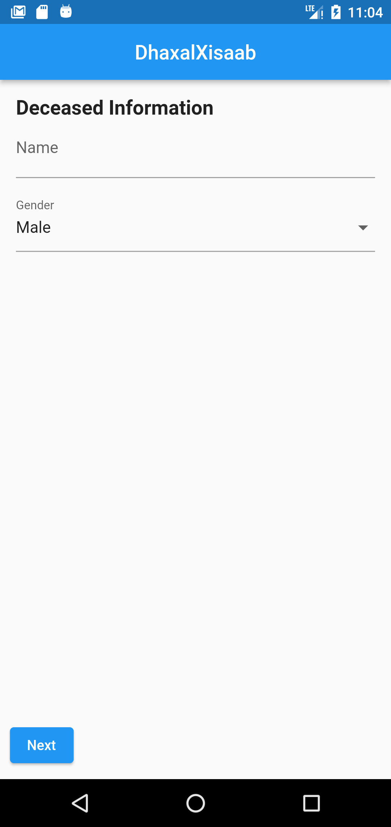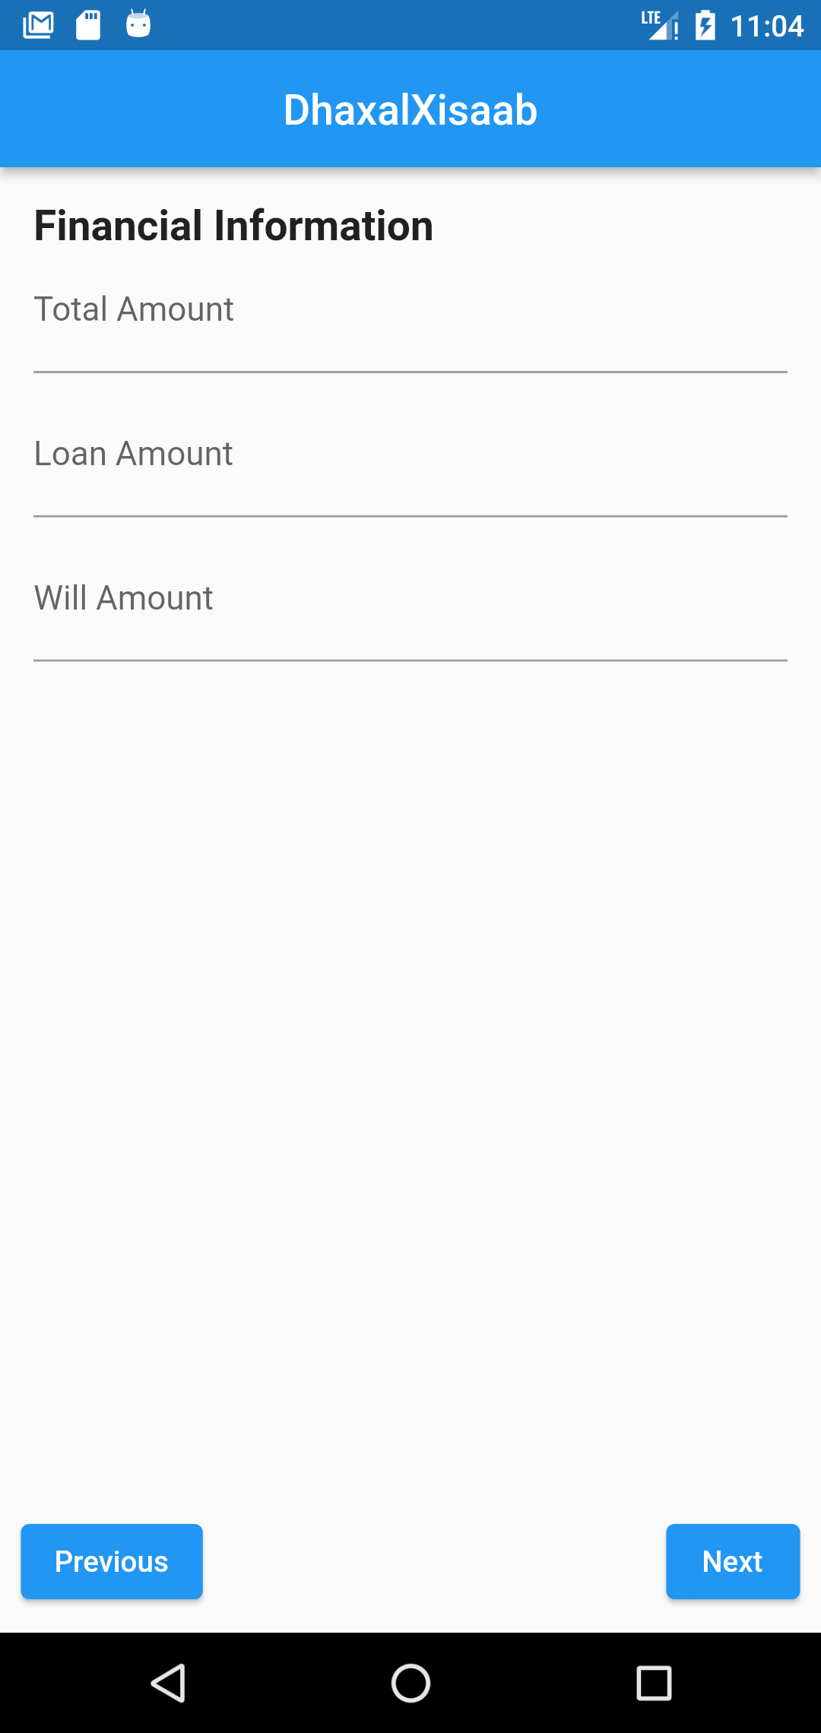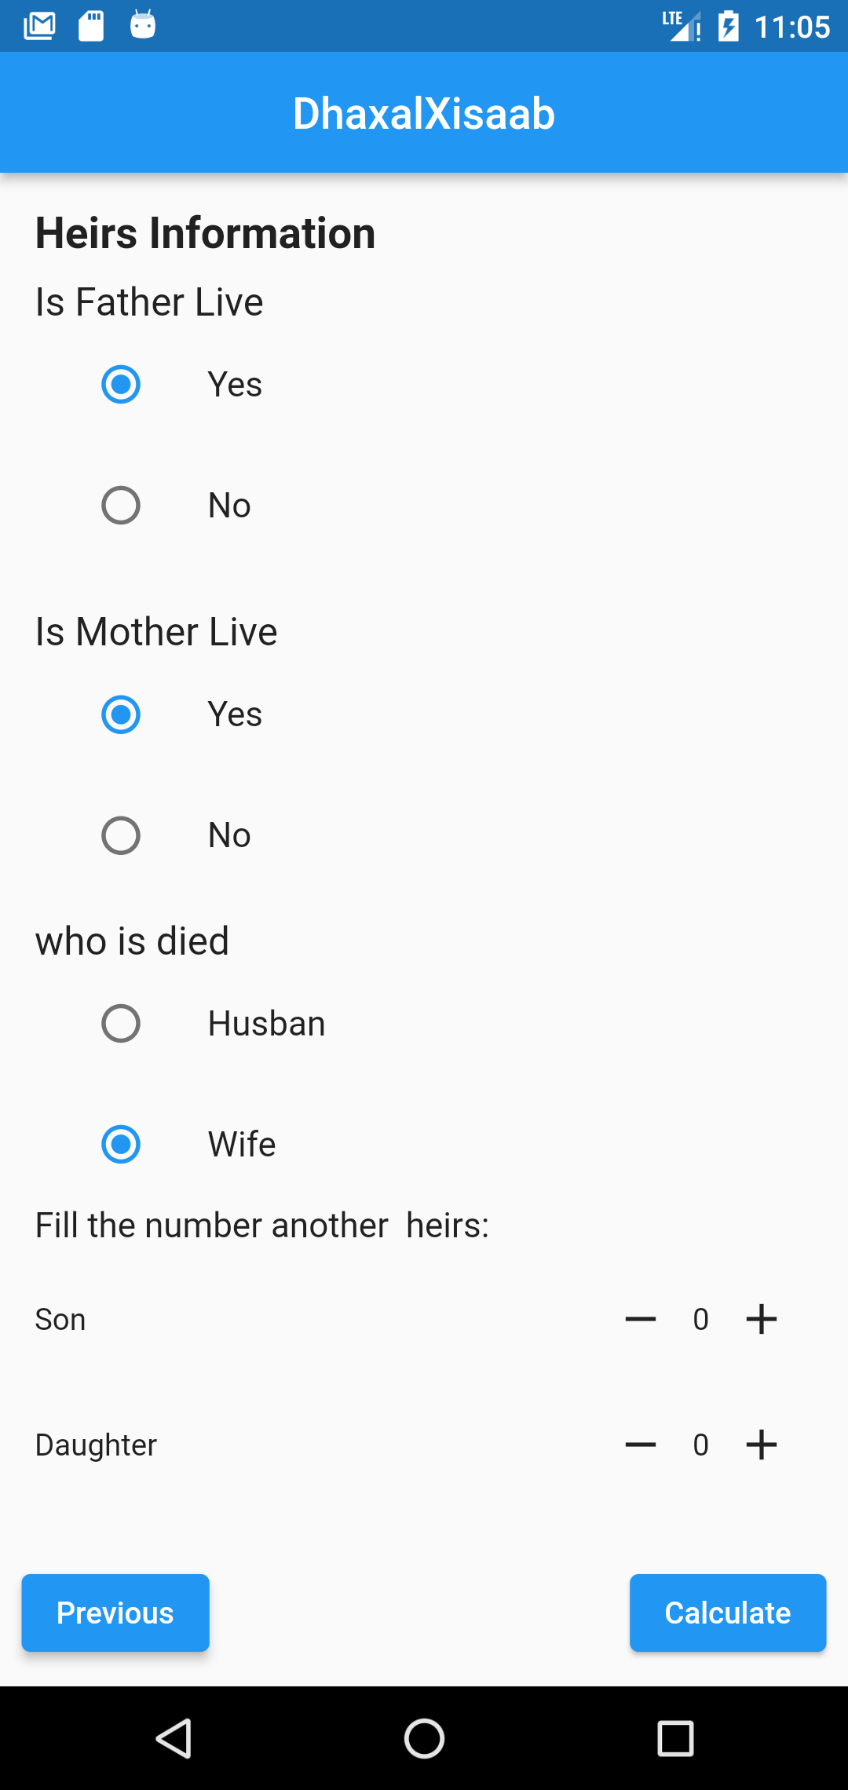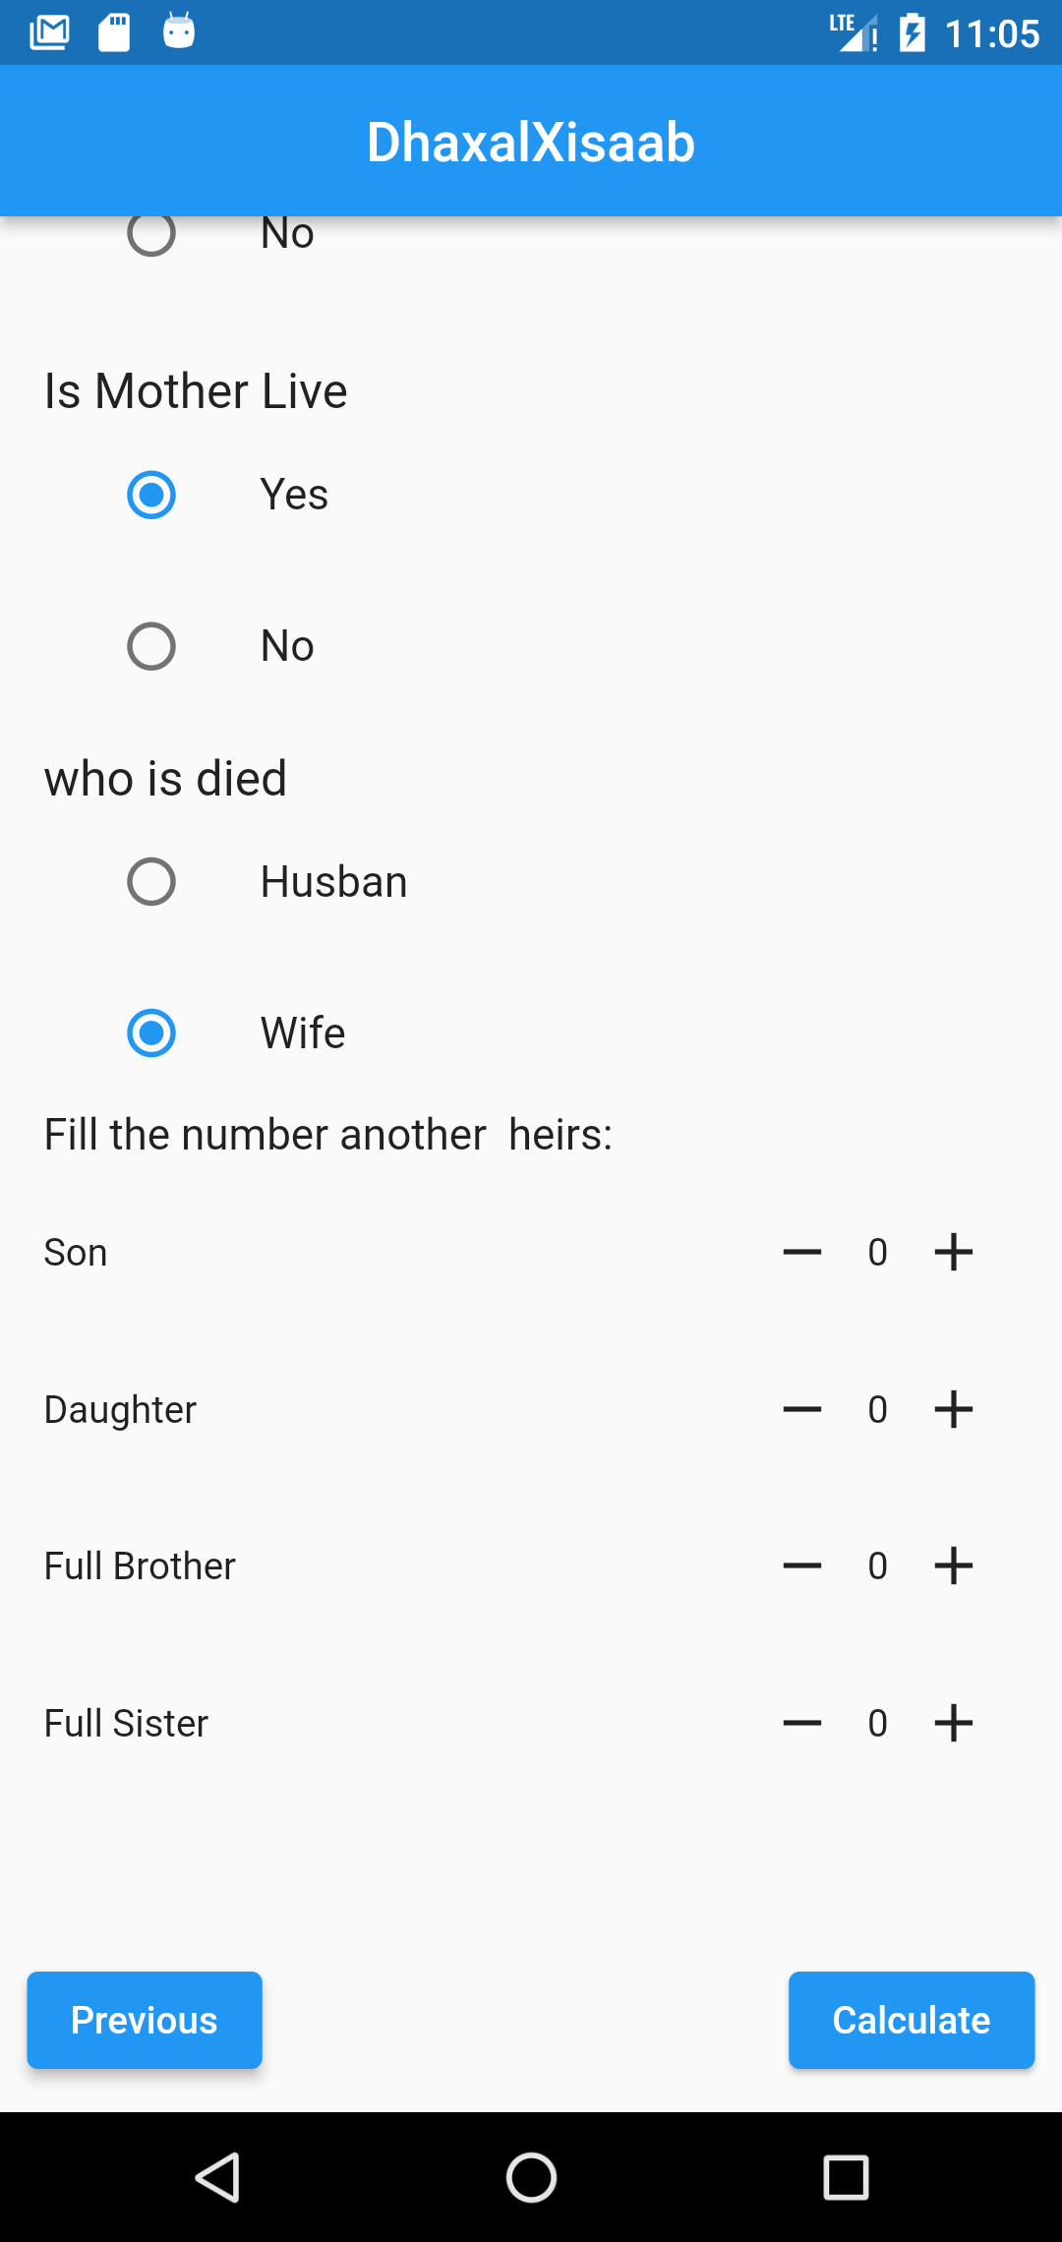

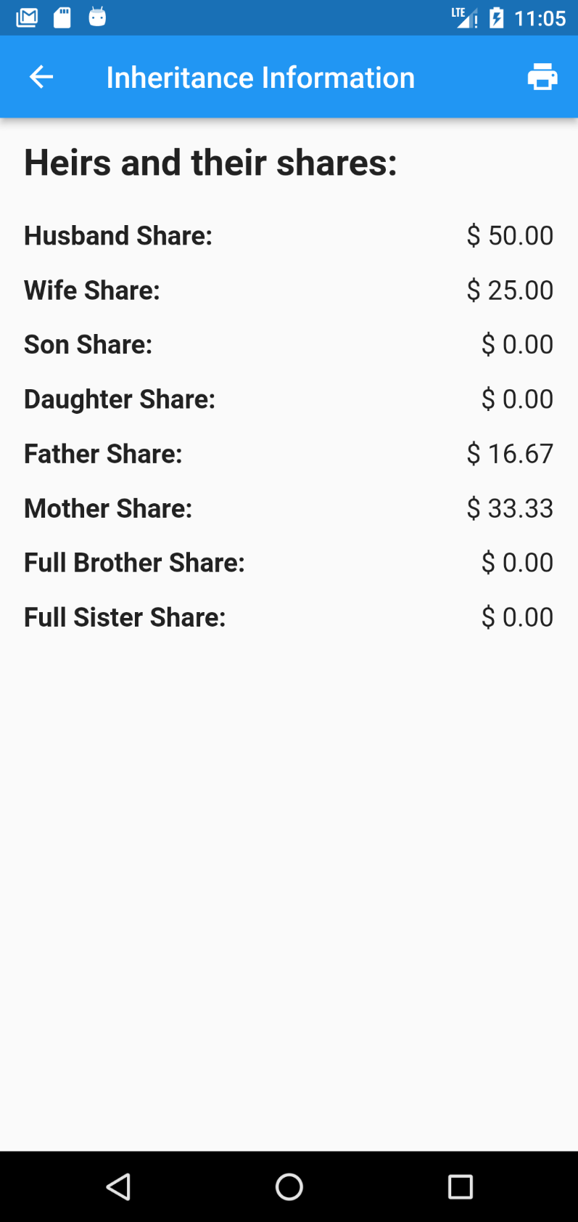

# **CONCLUSION**

# **REFERENCES**

Akriy, A. S., (1421 A.H). Madlabul-Nashidi: Sharhu Faradu Risalati ibn Abi Zaid Al- Qairawaaniy, Kano: Alh. Dahiru Mustapha Sagagi Publishers, pp.3-16.

Ali, S. H., (2003), Almirath: Justice of Islam in the rules of Inheritance, Pakistan: Al-Maktabah Al-Muhammedia Ghullah Mandi Publishers, pp. 15-39.

Bukhari, A. N., (2004). Inheritance in Islam, Al-Madinah Al-Munawwarah:

Al-Rasheed Printers, pp. 8-23.

Fibonacci, L. B., (2008). Fibonacci's De practica geometrie. Springer:

Munez Publishers, pp. 12.

Gandz, S. M., (1938). The Algebra of Inheritance: A Rehabilitation of Al-Khuwarizmi, University of Chicago Press, pp. 19-91.2

Hussain, D.A., (2003). Islamic Laws of Inheritance (Online) Available: Islam101.com/inheritance" <http://www.islam101.com/inheritance> Dated (25th July 2023).

Keffi, U. D., (1990). Some Aspects of Islamic Law of Succession, Kano: Rukhsa Publications, pp. 4-76.

Livio, M., (2003). The Golden Ratio, New York: Broadway Publishers, pp. 90-96. Mazumder, T. A., & Islam, D. M. R. (2018). Mobile Application and Its Global Impact. International Journal of Engineering & Technology IJET-IJENS, 06, 72–78.

Sabit, M. T. (2015). The Contemporary Application of Wasiyah (Muslim Will) In Malaysia. International Journal of Real Estate Studies, 9(1), 8–15.

Zuleika, A., & Desinthya, N.P. (2014). Islamic Inheritance Law (Faraid) and Its Economic Implication. Tazkia Islamic Finance and Business Review, 8.

Khosyi’ah, S & Irfan, Mohamad & Maylawati, Dian & Mukhlas, O. (2018). Analysis of Rules for Islamic Inheritance Law in Indonesia Using Hybrid Rule Based Learning. IOP Conference Series: Materials Science and Engineering. 288. 012133. 10.1088/1757-899X/288/1/012133.